**A PROJECT REPORT**

**Web Development using Python**

***Submitted by***

**Lathiya Isita Ravibhai**

**191110107020**

***In partial fulfilment for the award of the degree of***

**BACHELOR OF ENGINEERING**

**in**

**Department of computer Engineering**

**MAHAVIR SWAMI COLLEGE OF ENGINEERING AND TECHNOLOGY , SURAT**



**Gujarat Technological University, Ahmedabad**

**2022 - 2023**



**MAHAVIR SWAMI COLLEGE OF ENGINEERING AND TECHNOLOGY,**

**SURAT**

BMEF Campus, Bharthana Road, Vesu, Surat, Gujarat 395017

**CERTIFICATE**

This is to certify that the project report submitted along with the project entitled ***BACKEND DEVLOPER using Python*** has been carried out by ***ISITA RAVIBHAI LATHIYA*** under my guidance in partial fulfilment for the degree of Bachelor of Engineering in computer , 8th Semester of Gujarat Technological University, Ahmadabad during the academic year 2022-23.

Prof. Rauki Yadav Prof. C. H. Ridhi Naik

Internal Guide Head of the Department

Computer Dept.



Date: 06/05/2023

TO WHOM IT MAY CONCERN

This is to certify that Miss.Isita Ravibhai Lathiya, a student of Mahavir swami collage of engineering and technology , surat has successfully completed his summer internship in the field of Back-end Development (PYTHON,DJANGO) from 06/02/2023 to 06/08/2023 (Total number of Weeks: 24 - ONGOING) under the guidance of Sugandh Gupta.

His 8th Semester internship activities include Developing a WebApplication using Python,Django of Project titled EVIB(A Online Shopping Website For Chashmas).

During the period of his 8th Semester internship program with us, he had been exposed to different processes and was found diligent, hardworking and inquisitive.

We wish him every success in his life and career.

For Tops Technologies,



**MAHAVIR SWAMI COLLEGE OF ENGINEERING AND TECHNOLOGY, SURAT**

BMEF Campus, Bharthana Road, Vesu, Surat, Gujarat 395017

**DECLARATION**

We hereby declare that the Internship / Project report submitted along with the Internship / Project entitled ***EVIB(A Online Shopping Website For Chashmas using python)***  submitted in partial fulfillment for the degree of Bachelor of Engineering in Computer to Gujarat Technological University, Ahmedabad, is a Bonafede record of original project work carried out by me / us at Mahavir Swami College of Engineering And Technology under the supervision of ***Prof.Rauki Yadav*** and that no part of this report has been directly copied from any students’ reports or taken from any other source, without providing due reference.

|  |  |
| --- | --- |
| Name of the Student | Sign of Student |
|  |  |
|  |  |
|  |  |
| 1. Isita Lathiya | _____________ |

## Offer Letter



Completion Certificate



**Acknowledgments**

I would like to expand my heartiest much appreciated to Ms. Meghna Patel

(TOPS Tech. )for giving me an opportunity for an internship at The TOPS Tech. and supporting me in fact amid the period of internship and for supporting us amid the internship period. They guided me all the time and persuaded me inside their active plan.

Whole heartedly, I would like to thank Prof. Rauki Yadav for giving me the nonstop back and direction to seek after my last semester internship at “TOPS Tech” whereas picking up down to earth working encounter within the industry. In expansion, all the resources from our division give us a favorable environment and fundamental direction, without them I would not have accomplished my objective. They have continuously been accessible for any help and were continuously a awesome source of motivation for me.

## ABSTRACT

## The Internship has assisted me in the development of employer-valued skills such as teamwork, communications skills, and other technical skills. This Internship has exposed me to professional role models and mentors who have provided me support in the initial stages of my career in the IT industry by providing an example of the behaviours expected in the corporate world and by providing us knowledge from their experience. This Internship has provided me with knowledge of many technical skills and taught me how to use them in solving real-world problems. This Internship has provided me an opportunity to work on a real-world project by which I learn how to develop a project by using the software development life cycle, how to work as a team, and how to aggregate all knowledge in solving Puzzles.

List of Figures

|  |  |  |  |
| --- | --- | --- | --- |
| Sr. No. | Content |  | Pg. No. |
| 1 | Fig 1.1 | Organization chart | 2 |
| 2 | Fig 1.2 | Function use | 6 |
| 3 | Fig 1.3 | Django cycle | 7 |
| 4 | Fig 1.4 | SQLite Download and Installation | 9 |
| 5 | Fig 1.5 | Buyer side | 21 |
| 6 | Fig 1.6 | Seller side | 22 |
| 7 | Fig 1.7 | File and Folder Structure | 25 |
| 8 | Fig 1.8 | Landing page | 26 |
| 9 | Fig 1.9 | Register page | 27 |
| 10 | Fig 1.10 | login page | 27 |
| 11 | Fig 1.11 | OTP page | 28 |
| 12 | Fig 1.12 | profile Pic | 28 |
| 13 | Fig 1.13 | View product page | 29 |
| 14 | Fig 1.14 | Product description page | 29 |
| 15 | Fig 1.15 | Shopping cart page | 30 |
| 16 | Fig 1.16 | Payment gateway page | 30 |
| 17 | Fig 1.17 | Seller register page | 31 |
| 18 | Fig 1.18 | Seller login page | 31 |
| 19 | Fig 1.19 | Add product page | 32 |
| 20 | Fig 1.20 | Forgot password | 32 |
| 21 | Fig 1.21 | Reset password | 33 |

Table Of Contents

|  |  |  |
| --- | --- | --- |
| Sr. No. | Content | Pg. No. |
| 1 | First Page | I |
| 2 | College Certificate | II |
| 3 | Company Certificate | III |
| 4 | Candidate’s Declaration | IV |
| 5 | Offer Letter | V |
| 6 | Completion Certificate | VI |
| 7 | Acknowledgment | VIII |
| 8 | Abstract | IX |
| 9 | List of Figures | X |
| 10 | List of Tables | XII |
| 11 | Table of Contents | XIII |
| 12 | Chapter – 1: Overview of Company  1.1 About the Company  1.2 Organization chart  1.3 Work, Product and Services of the Company | 1  2  2 |
| 13 | Chapter – 2: Introduction  2.1 Project Summary  2.2 Purpose  2.3 Scope  2.4 Objective  2.5 Technology  2.5.1 PYTHON  2.5.2 DJANGO  2.5.3 DBBROWSER(SQLLITE) | 3  3  4  5  6  7  7  8  9  9 |

|  |  |  |
| --- | --- | --- |
| 14 | Chapter – 3: Project Management  3.1 Existing System  3.2 Need for the New System  3.3 Objective of New System  3.4 Problem Definition  3.5 Core Component  3.6 Project Profile  3.7 Assumption and Constraints  3.8 Advantages and Limitations of the Proposed System | 10  10  10  11  11  11  12  12  12 |
| 15 | Chapter – 4: System Requirement  4.1 Requirement Determination and analysis  4.2 Requirement Determination  4.3 System requirements | 13  24  15  16 |
| 16 | Chapter – 5: System Analysis  5.1 Feasibility Study  5.2 Functional Requirement  5.3 Non-Functional Requirement | 17  17  18  19 |
| 17 | Chapter – 6: System Design  6.1 Target Users  6.2 Use Case Diagram  6.3 Data Dictionary | 20  21  22  22 |
| 18 | Chapter – 7: Implementation  7.1 Technologies Implementation Environment  7.2 Security Features  7.3 Coding Standards  7.4 Prototype Screen Shots  7.5 Working Task Screen Shots | 23  26  29  31  32  33 |
| 19 | Chapter – 8: Testing  9.1 Testing Plan  9.2 Testing Strategy  9.3 Test Case | 34  34  35  35 |
| 20 | Chapter – 9: Conclusion and Discussion  10.1 Problem Encountered and Possible Solutions | 36  36 |
| 21 | Chapter – 10: Limitation and Features Enhancement  11.1 Advantage  11.2 Disadvantage | 37  37  37 |

|  |  |  |
| --- | --- | --- |
| 22 | Conclusion | 39 |
| 23 | References | 40 |

### Chapter – 1: Overview of Company

1.1 About the Company

Name: Tops Technologies

Address: 407 Dhara Arcade Opp Swaminarayan temple, Mahadev Chowk MotaVarachha Surat 394101 Gujarat

Website: www.thesunflowerlab.com

Phone no.: +91 73830 23957

About:

Tops technologies is a company offering services in the field of Software Development, Website Development, Mobile App Development, Graphic Designing, Digital Marketing, Testing & QA, Bulk SMS & Hosting Provider and IT Consultancy . In Terms Of Services, Designing and Coding. Services include customized Software Development, Website Development And Programming, Mobile App Development, Graphic Designing, Digital Marketing, Testing & QA, Bulk SMS & Hosting Provider And IT Consultancy and Maintenance. Company has a vast experience in development for Software/Web And Mobile Application. Our Processes are highly streamlined and proven to ensure fastest delivery of a high quality solution at a reasonable cost. We understand our client's need and changes over period of time. We have expertise to accommodate changes at any stage of software lifecycle.

1.2 Organization chart

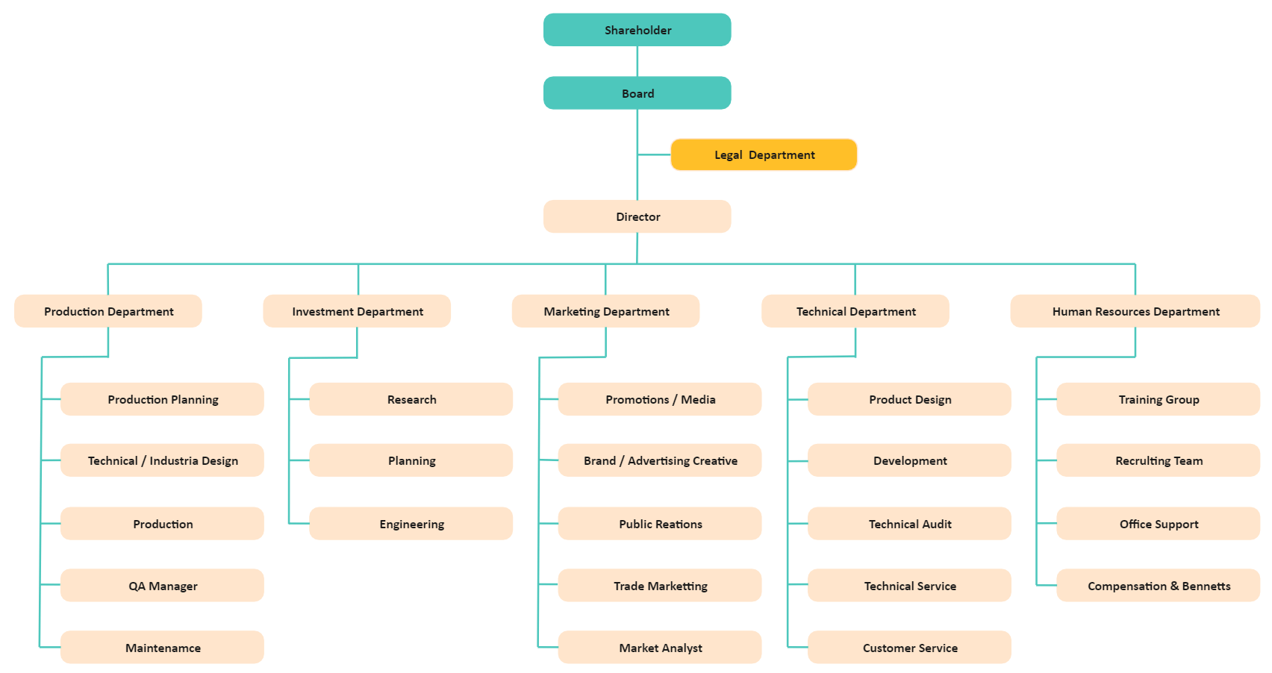

Fig 1.1 Organization chart

1.3 Work, Product and Services of the Company

We Provide A Wide Range Of Web Solutions Such As Professional Website Design And Development, Customized Software Development, Website Development And Programming, Mobile App Development, Graphic Designing, Digital Marketing, Testing & QA, Bulk SMS & Hosting Provider And IT Consultancy To A Wide Range Of Clients. We Give Our First Priority To Our Client Satisfaction. We Solve Any Query Of Our Customer With Appropriate Explanations And Also Adopt Their Ideas After Proper Discussions. We Are Available At Any Time According To Our Clients Requirement. We Do Our Best To Ful fill The Requirement Of Our Clients. We Deliver Our Product On Time And To Every Specification. We Accurately Follow The Best And Usual Web Developing Life Cycle Which Is: Planning, Analysis, Design, Implementing And Review.

**Why Choose Us?**

Tops Technologies is a company in offering services in the field of Software development, Website Development, Mobile Application Development and Customized ERP Solutions.

### Chapter – 2: Introduction

Online shopping (sometimes known as e-tail from "electronic retail" or e-shopping) is a form of electronic commerce which allows consumers to directly buy goods or services from a seller over the Internet using a web browser. Alternative names are: e-web-store, e-shop, e-store, Internet shop, web-shop, web-store, online store, online storefront and virtual store. mobile commerce (or m-commerce) describes purchasing from an online retailers mobile optimized online site or app. An online shop evokes the physical analogy of buying products or services at a bricks-and-mortar retailer or shopping center the process is called business-to-consumer (B2C) online hopping. In the case where a business buys from another business the process is called business-to-business (B2B) online shopping.

#### 2.1 Project Summary

In summary, ***EVIB(A Online Shopping Website For Chashmas using python)***  is a Web Application that is helpful for recommend the product as per your choice.

In this modern era technology developed day by day all things we can do on the online .This web application is one of the best example for that. Nowadays ,most of optical shop have this type of websites for the online support.

#### 2.2 Purpose

Unlike a physical shop, an online store does not need a space to rent, so you don’t need to worry about paying rent, or electricity fee, or any other fees that come with renting a space. That’s a lot of savings you can invest in promoting and growing your business! Plus, online stores are open round the clock, always ready to sell to buyers worldwide at no extra cost. Around the clock e-commerce websites are very valuable and will enhance your business.

#### 2.3 Scope

#### Before we launch into the future and scope of eCommerce in India, let us first understand what is e-commerce. To put it simply, electronic commerce refers to the purchase and sale of goods online or via the internet.

#### 2.4 Objective

The main goals of online shopping systems are to it has great advantages over real markets. Many online stores are giving their best services to the people. The system of online shopping has increased it so vast. By sitting at any corner of the world you can avail the services. Due to the online shopping system, you can shop for any product from any place and get the delivery at your home. This online system has made it possible to approach any world’s market easily.

2.5 Technology

2.5.1 PYTHON

2.5.2 DJANGO

2.5.3 DBBROWSER(SQLLITE)

2.5.1 PYTHON

# **Introduction with Python**

* Python is an interpreted, object-oriented, high-level programming language with dynamic semantics.
* Its high-level built in data structures, combined with dynamic typing and dynamic binding, make it very attractive for Rapid Application Development.
* Python supports modules and packages, which encourages program modularity and code reuse.
* The Python interpreter and the extensive standard library are available in source or binary form without charge for all major platforms, and can be freely distributed.

# **Why Python?**

* to be easy to learn and master
* Clean, clear syntax
* Very few keywords
* Highly portable
* Runs almost anywhere - high end servers and workstations, down to windows CE
* Uses machine independent byte-code
* Extensible
* Designed to be extensible using C/C++,
* allowing access to many external libraries

# **Features of Python**

* Clean syntax plus high-level data types
* Leads to fast coding (First language in many universities abroad!)
* Uses white-space to delimit blocks
* Humans generally do, so why not the language?
* Try it, you will end up liking it
* Variables do not need declaration
* Although not a type-less language

# Python Productivity

* Reduced development time
* code is 2-10x shorter than C, C++, Java
* Improved program maintenance
* code is extremely readable
* Less training
* language is very easy to learn

# **OOPS in Python**

* Python has been an object-oriented language since it existed. Because of this, creating and using classes and objects are downright easy.
* Overview of OOP Terminology
* **Class:** A user-defined prototype for an object that defines a set of attributes that characterize any object of the class. The attributes are data members (class variables and instance variables) and methods, accessed via dot notation.
* **Class variable:** A variable that is shared by all instances of a class. Class variables are defined within a class but outside any of the class's methods. Class variables are not used as frequently as instance variables are.
* **Data member:** A class variable or instance variable that holds data associated with a class and its objects.
* **Function overloading:** The assignment of more than one behavior to a particular function. The operation performed varies by the types of objects or arguments involved.
* **Instance variable:** A variable that is defined inside a method and belongs only to the current instance of a class.
* **Inheritance:** The transfer of the characteristics of a class to other classes that are derived from it.
* **Instance:** An individual object of a certain class. An object obj that belongs to a class Circle, for example, is an instance of the class Circle.
* **Instantiation:** The creation of an instance of a class.
* Method: A special kind of function that is defined in a class definition.
* **Object:** A unique instance of a data structure that's defined by its class. An object comprises both data members (class variables and instance variables) and methods.
* **Operator overloading:** The assignment of more than one function to a particular operator.

**Python Function**

* Python Built-in Functions.
* Python Recursion Functions.
* Python Lambda Functions.

**Python Function Declaration**

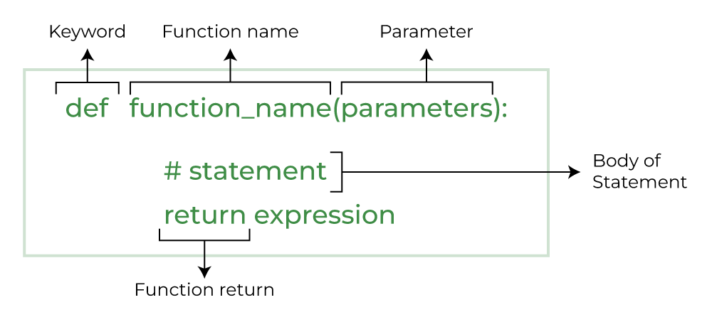

Fig 1.2 Function use

#### 2.5.2 DJANGO

* Virtual Environment
* Installation Migration
* Settings.py
* Creating application
* Models

# **What is Django?**

* Django is a free and open source web application framework, written in Python. A web framework is a set of components that helps you to develop websites faster and easier.
* When you're building a website, you always need a similar set of components: a way to handle user authentication (signing up, signing in, signing out), a management panel for your website, forms, a way to upload files, etc.
* To understand what Django is actually for, we need to take a closer look at the servers. o The first thing is that the server needs to know that you want it to serve you a web page.
* Imagine a mailbox (port) which is monitored for incoming letters (requests). This is done by a web server.
* The web server reads the letter and then sends a response with a webpage. o But when you want to send something, you need to have some content. And Django is something that helps you create the content.

# **How It Works?**

* When a request comes to a web server, it's passed to Django which tries to figure out what is actually requested.
* It takes a web page address first and tries to figure out what to do. This part is done by Django's url resolver (note that a website address is called a URL – Uniform Resource Locator – so the name url resolver makes sense).
* It is not very smart – it takes a list of patterns and tries to match the URL. Django checks patterns from top to bottom and if something is matched, then Django passes the request to the associated function (which is called *view*).

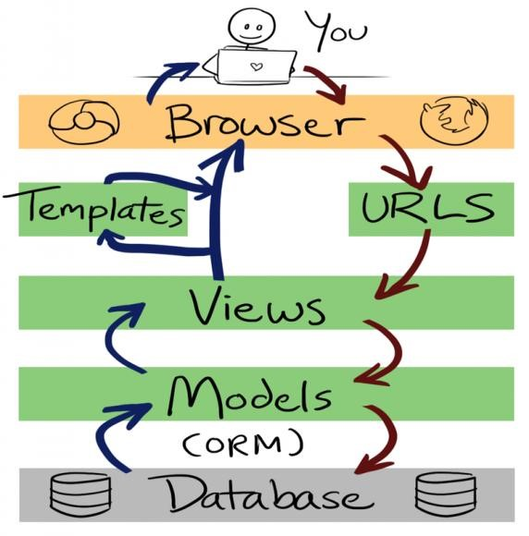

Fig 1.3 django cycle

# **Django Installation**

* **Virtual environment** 
  + - Before we install Django we will get you to install an extremely useful tool to help keep your coding environment tidy on your computer.
    - It's possible to skip this step, but it's highly recommended.
    - So, let's create a virtual environment (also called a *virtual env*). Virtual env will isolate your Python/Django setup on a per-project basis.
    - This means that any changes you make to one website won't affect any others you're also developing
    - All you need to do is find a directory in which you want to create the virtual env;
    - For windows ,
    - To create a new virtual env ,you need to open the console and run C:\Python35\python –m venv myvenv.
    - It will look like this:
    - Command-line
    - C:\Users\Name\djangogirls> C:\Python35\python –m venv myvenv where C:\Python35\python is the directory in which python is installed and ‘myvenv’ is the name of your virtualenv.
    - **Working with virtualenv**
    - The command above will create a directory called ‘myvenv’ that contains our virtual environment.
    - Start your virtual environment by running :
    - Command line :
    - C:\Users\Name\djangogirls>myvenv\Scripts\activate
    - Now that you have your virtual env started ,you can install Django.

Before we do that, we should make sure we have the latest version of pip, the software that we use to install Django.

#### 2.5.3 DBBROWSER(SQLLITE)

**What is SQLite Browser?**

DB Browser for SQLite (DB4S) is a high quality, visual, open-source tool made for creating, designing, and editing database files that are compatible with SQLite. It is for users and developers who want to create, search, design and edit [databases](https://www.edureka.co/blog/what-is-a-database/). SQLite browser uses a general spreadsheet-like interface, and there is no need to learn complicated [SQL commands](https://www.edureka.co/blog/sql-commands). It is a tool that is used by both developers and end-users, and for that reason, it has to remain as simple as possible. There are many SQLite browsers available on the internet under the name “DB Browser for SQLite”.

## **Uses of SQLite Browser**

It is a tool that lets us view the data that is stored in an SQLite Database. Depending on the format and type of data in the database it may or may not be readable by a human. This is generally used for debugging or other development tasks where the developer needs to read the data that has been stored but does not have a built-in system to access it through the program.

**Some controls and wizards are available in SQLite browsers for users to:**

* Create and compact database files
* Create, define, modify and delete tables
* Create, define and delete indexes
* Browse, edit, add, search and delete records
* Import and export records as text
* Import and export tables from/to CSV files
* Issue [SQL queries](https://www.edureka.co/blog/insert-query-sql/) and inspect the results
* Examine log of all the SQL commands issued by the application

## **How to Install SQLite browser?**

**Follow these steps to install in windows:**

* Open your favourite browser and search for SQLite and the first link will show up which is [www.sqlite.org.](http://www.sqlite.org/)
* Click on the Download link.
* In the downloads page, scroll down a little where ‘pre-compiled binaries for windows’ are present.
* Select the last option which says SQLite tools-windows32-s86 which is a zip file, download it

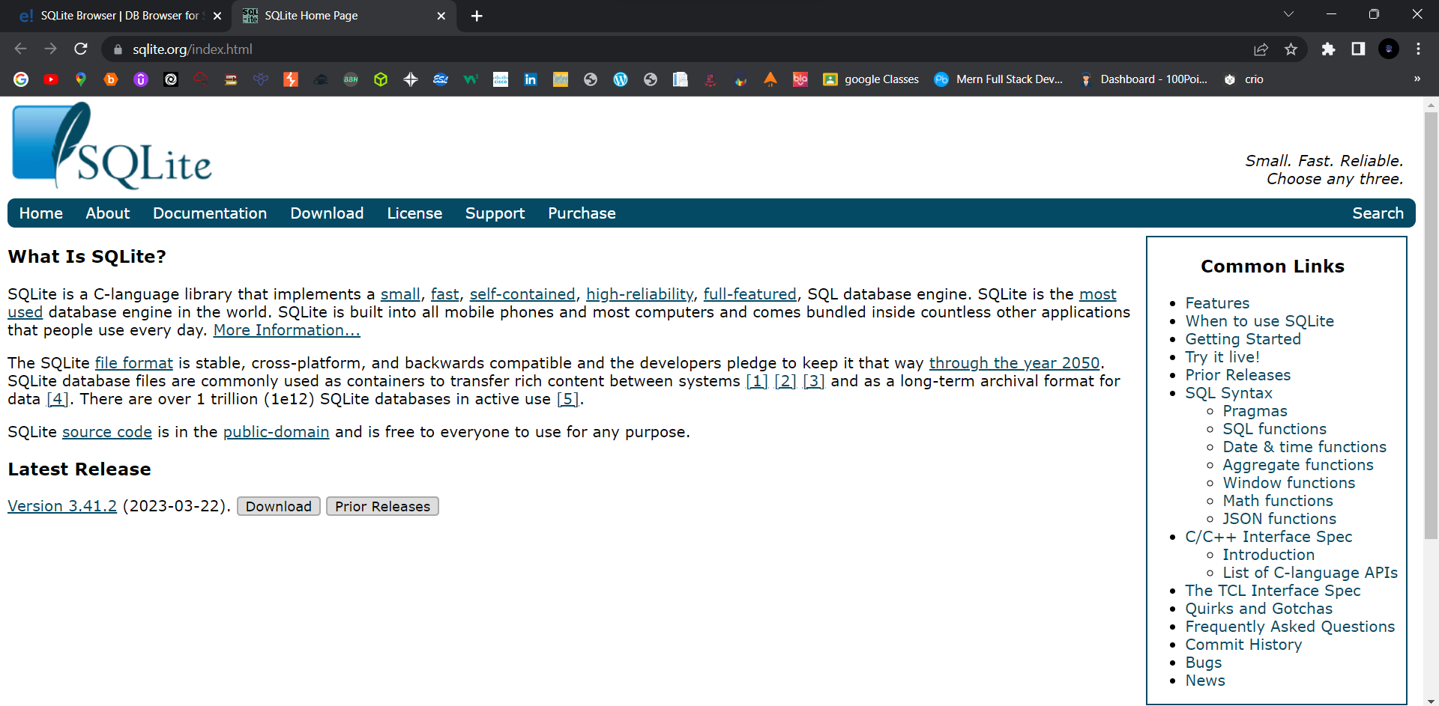

Fig 1.4 SQLite download and installation

### Chapter – 3: Project Management

#### 3.1 Existing System

Collaborative filtering, content-based, knowledge-based, and hybrid approaches are the basic recommendation techniques that can be used in a online shopping website. Besides, other algorithms are also applied to generate recommendations in the project, such as an colony algorithm, classification, clustering, decision tree, logistic regression , natural language processing, inductive logic programming , ontologies, sparse canonical correlation, support vector machines ,semantic technologies, multi-criteria decision making, graph-based recommendations, context-aware recommendation , and matrix factorization . In this section, we present basic techniques applied in the project.

#### 3.2 Need for the New System

There are three main aspects that need to be considered in recommender systems: usage context, users, and items . Usage context describes the environment where all elements interact with each other. Users are the end-users of recommender systems, and items are the elements that users are looking for. In the website.

#### 3.3 Objective of New System

The primary objectives of online shopping are to:

* Manage the shopping details
* Manage the payment details
* Generate the information of customers and products
* Reduce the cost of management

#### 3.4 Problem Definition

There are a lot of websites on internet whereby it offer a variety of product and services for consumer can find and buy through online such as shoe, apparel, sun glasses and more Moreover, the online also provides some of the services which is paying bill online, booking a transport ticket and more. In this research, we are looking the problem addressed in this research which is the view of online shopping by consumer.3.5 Core Component

There are Different Types of App Component :

1. Login
2. Buyer
3. Seller
4. Product recommendations

#### 3.6 Project Profile

* Type: online optical recommendations
* Modules: product name, product description, add product
* Target users: all citizen
* Features: advance technology, all product recommendation as per fashion
* Benefits: online shopping

#### 3.7 Assumption and Constraints

Assumptions:

1. The users of the system have basic computer knowledge and can operate the software with minimal training.
2. The system will be accessible through web browsers and mobile devices.
3. The system will be scalable to accommodate the growth of the organization.
4. The system will be customizable to meet the specific needs of different organizations.
5. The system will comply with data privacy regulations.
6. The implementation and integration of the health product recommendation system will not disrupt the organization's daily operations.
7. The system will be tested for performance and security before implementation.

Constraints:

1. The development team must work within the budget allocated for the project.
2. The development team must work within the timeline established for the project.
3. The system must be compatible with the existing infrastructure and technology used by the organization.
4. The organization must provide the necessary data and resources to implement and operate the system.
5. The system must be user-friendly and easy to use, requiring minimal training for users.
6. The system must be reliable and available 24/7 to ensure uninterrupted operations.
7. The organization must ensure data privacy and security to prevent unauthorized access or breaches.

#### 3.8 Advantages and Limitations of the Proposed System

Advantages of online shopping website:

* Time Convenience
* Price Comparisons
* Discount And Notification
* Infinite Choice
* No Size Limitations
* Zero Parking Struggle

Limitations of online shopping website:

* You Can’t Always talk To Someone Immediately
* Must Wait for Delivery
* Shipping Costs
* Privacy and Security

### Chapter – 4: System Requirement

#### 4.1 Requirement Determination and analysis

Requirement determination and analysis is a crucial process in the development of the online shopping website project. This involves gathering and analysing the needs and expectations of the users, stakeholders, and business requirements.

The following are the requirements identified for each module of the SF-HRMS system:

1. Sales-Sprout Module:
   * Capability to generate and manage leads
   * Sales forecasting and pipeline management
   * Automated sales processes
   * Real-time tracking of sales performance and metrics
   * Integration with the Inventory Management module

1. Inventory Management Module:
   * Real-time tracking of inventory levels and stock movements
   * Automatic inventory alerts and notifications
   * Ability to create and manage purchase orders
   * Integration with the Sales-Sprout module
   * Customizable inventory reports and dashboards

1. Expense Management Module:
   * Ability to track and manage employee expenses
   * Integration with payroll and HR systems
   * Customizable expense categories and approval workflows
   * Real-time tracking of expense reimbursements
   * Secure and compliant expense data management

1. Scheduler Module:
   * Automated scheduling and shift management
   * Availability tracking and management
   * Customizable scheduling rules and policies
   * Integration with payroll and HR systems
   * Real-time visibility of employee schedules

The requirements gathering and analysis also identified the following system requirements:

* + Cloud-based system for ease of access and scalability
  + Mobile compatibility for remote access
  + Secure data storage and management
  + Customizable user interface and access levels
  + Compliance with data privacy and security regulations.

These requirements and constraints were analysed and incorporated into the development of the OSW system to ensure that it meets the needs of the users and stakeholders, and also complies with regulatory requirements.

#### 4.2 Requirement Determination

Requirement determination for OSW includes the following:

1. Sales-Sprout Module: The system should be able to manage the entire sales process, including lead management, opportunity tracking, deal closing, and sales forecasting. It should be able to generate reports on sales performance, pipeline status, and other key metrics.

1. Inventory Management Module: The system should be able to track inventory levels, monitor stock movements, and generate reports on inventory status. It should have features for managing stock levels, setting reorder points, and receiving notifications for low stock levels.

1. Expense Management Module: The system should be able to track employee expenses, including travel expenses, office expenses, and other reimbursements. It should have a user-friendly interface for employees to submit expense reports and for managers to approve or reject expenses.

1. Scheduler Module: The system should have a user-friendly interface for managing employee schedules, including shift scheduling, leave management, and attendance tracking. It should also have features for generating reports on attendance, leave balances, and other key metrics.

1. Security: The system should have robust security features, including data encryption, role-based access control, and user authentication. It should be compliant with various data privacy regulations and standards.

1. Scalability: The system should be scalable and able to handle a large number of users and transactions. It should be able to accommodate future growth and expansion.

1. Customizability: The system should be customizable to meet the specific needs and requirements of each organization. It should have features for configuring workflows, creating custom fields, and integrating with other systems.

1. Integration: The system should be able to integrate with other systems, such as payroll systems, accounting systems, and CRM systems, to streamline business processes and improve efficiency.

#### 4.3 System requirements

1. Hardware Requirements:
   * + Processor: Intel Core i5 or higher
     + RAM: 8GB or more
     + Storage: 500GB HDD or higher
     + Display: 1366 x 768 resolution or higher
     + Internet connectivity

1. Software Requirements:
   * + Operating System: Windows 10 or higher
     + Web Browser: Google Chrome, Mozilla Firefox, Safari, Microsoft Edge
     + Text Editor: Visual Studio Code or any other compatible text editor (Ref 1.1)
     + Python 3.11
     + Django 4.2.1

1. System Functional Requirements:
   * + User authentication and authorization
     + Sales-Sprout module with the ability to add, edit, and delete sales orders
     + Inventory Management module with the ability to add, edit, and delete inventory items
     + Expense Management module with the ability to add, edit, and delete expenses
     + Schedular module with the ability to schedule tasks and events
     + Dashboard with graphical representation of data
     + Reporting functionality with the ability to generate reports in PDF or CSV format

1. System Non-Functional Requirements:
   * Security: The system should have measures in place to prevent unauthorized access, data breaches, and cyber attacks.
   * Performance: The system should be able to handle a large amount of data and user traffic without significant performance issues.
   * Usability: The system should have a user-friendly interface with clear and concise instructions.
   * Accessibility: The system should be accessible to users with disabilities.
   * Scalability: The system should be able to scale up or down depending on the business needs.

### Chapter – 5: System Analysis

#### 5.1 Feasibility Study

Feasibility study is an important phase in the project management lifecycle. It determines the practicality of the project and assesses whether the project is worth pursuing. Here is a feasibility study for the online shopping website:

1. Technical Feasibility: The project will be implemented using Angular, a widely used web application framework. The team has sufficient technical expertise in Angular to develop the system. The necessary hardware and software resources are also available.

1. Economic Feasibility: The project will involve some upfront costs for hardware, software, and personnel. However, the benefits of the project, such as improved efficiency and productivity, are expected to outweigh the costs in the long run.

1. Operational Feasibility: The health product recommendation project is designed to streamline HR processes and improve overall efficiency. It is expected that the project will be readily accepted by end-users and will help to achieve organizational goals.

1. Schedule Feasibility: The project is expected to take approximately 6-9 months to complete. The schedule is feasible, given the availability of resources and expertise.

1. Legal Feasibility: The health product recommendation project must comply with data privacy and protection regulations, such as GDPR and CCPA. The team will ensure that the system is fully compliant with all applicable laws and regulations.

Based on the above feasibility analysis, it can be concluded that the OSW project is feasible and worth pursuing.

#### 5.2 Functional Requirement

The functional requirements of the OSW project include:

1. Sales-Sprout module:

* The system should allow users to create and manage sales orders.
* The system should allow users to track the status of sales orders.
* The system should allow users to generate sales reports.

2. Inventory Management module:

* The system should allow users to track inventory levels.
* The system should allow users to create and manage purchase orders.
* The system should allow users to generate inventory reports.

3. Expense Management module:

* The system should allow users to submit expense reports.
* The system should allow users to track the status of expense reports.
* The system should allow managers to approve or reject expense reports.

4. Scheduler module:

* The system should allow managers to create and manage employee schedules.
* The system should allow employees to view their schedules.
* The system should allow managers to generate schedule reports.

5. User Management module:

* The system should allow administrators to create and manage user accounts.
* The system should allow administrators to set user permissions.

6. Reporting and Analytics module:

* The system should provide advanced reporting and analytics capabilities.
* The system should allow users to generate customizable reports and dashboards.
* The system should allow users to track key performance indicators (KPIs) and metrics.

7. Compliance module:

* The system should comply with various data privacy regulations.
* The system should ensure data security and confidentiality.
* The system should provide audit trails and record-keeping features.

#### 5.3 Non-Functional Requirement

Non-functional requirements of the OSW project could include:

1. Performance: The system must be responsive and efficient, with a fast response time for user interactions, even with large amounts of data.

1. Scalability: The system should be scalable to accommodate future growth and changes in the business requirements.

1. Security: The system must be secure to prevent unauthorized access, data theft, and data loss. It should also comply with data protection regulations and policies.

1. Usability: The system must be user-friendly and intuitive, with a simple and easy-to use interface for all users.

1. Reliability: The system must be reliable and available, with minimal downtime or disruption to operations.

1. Compatibility: The system must be compatible with different devices, platforms, and browsers to ensure that it can be used by all users.

1. Maintainability: The system must be easy to maintain and update, with a robust and flexible architecture that supports changes and modifications as required.

1. Accessibility: The system must be accessible to users with disabilities, and comply with accessibility standards and regulations.

### Chapter – 6: System Design

#### 6.1 Target Users

The target users of the OSW project may include:

1. HR Managers: They would use the system to manage and monitor employee information, attendance, leave, performance, and other related tasks.

1. Employees: They can use the system to check their own attendance, leave balances, pay stubs, and other personal information.

1. Sales and Marketing Teams: They would use the Sales-Sprout module to manage and track sales leads, opportunities, and performance.

1. Inventory Managers: They would use the Inventory Management module to monitor and manage stock levels, orders, and purchase orders.

1. Finance Teams: They would use the Expense Management module to track and manage expenses, reimbursements, and budgets.

1. Managers and Supervisors: They would use the Schedular module to schedule employee shifts, assign tasks, and manage workloads.

Overall, the a online shopping website is designed to cater to the needs of HR departments, sales and marketing teams, inventory and finance departments, and managers who need to manage and monitor employee and business-related tasks efficiently.

Design

#### 6.2 Use Case Diagram

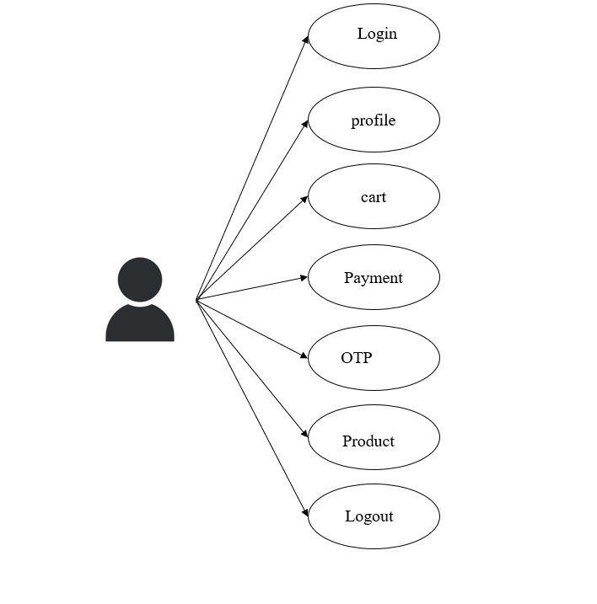

Fig 1.5 buyer side

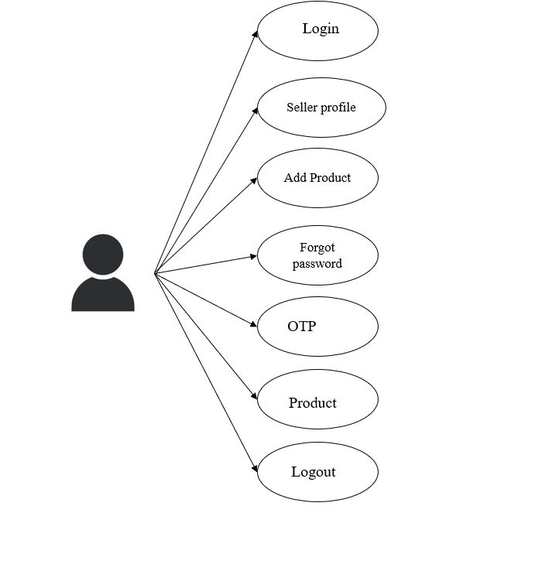

Fig 1.6 seller side

### Chapter – 7: Implementation

#### 7.1 Technologies Implementation Environment

Front-end Technologies:

* HTML, CSS, and JavaScript for creating web pages
* Bootstrap for responsive design and layout
* Angular Material for UI components

Back-end Technologies:

* python
* Django
* DB Browser(SQL Lite)
* MYSQL

Development Tools:

* Visual Studio IDE for coding and debugging
* GitLab for version control and source code management
* Postman for API testing

#### 7.2 Security Features

1. Role-based access control: User roles can be defined and assigned varying levels of access to different modules and features within the system. This ensures that users can only view and modify data that is relevant to their job functions.

1. Authentication: Require users to enter valid login credentials to access the system, such as a username and password. Use strong password policies, such as minimum length and complexity requirements, to ensure that user accounts are secure.

1. Authorization: Implement role-based access control to restrict access to sensitive features and data. Users should only be able to access the features and data that they are authorized to view or modify based on their roles and permissions.

1. Encryption: Encrypt sensitive data, such as passwords, credit card information, and personal identification numbers (PINs), to protect them from unauthorized access. Use industry-standard encryption algorithms and keys to ensure that the data cannot be easily decrypted.

1. Input validation: Validate all input data to prevent injection attacks, such as SQL injection and cross-site scripting (XSS). Use server-side validation to check for invalid characters and data types to prevent malicious code from executing.

1. Error handling: Implement error handling to prevent attackers from exploiting system vulnerabilities by intercepting error messages. Provide clear and concise error messages that do not reveal sensitive system information.

1. Session management: Manage user sessions securely to prevent session hijacking and replay attacks. Implement session timeouts and use secure session IDs to ensure that sessions are not hijacked.

1. Audit logging: Record all system activities, such as login attempts, data modifications, and system events, to track user actions and detect suspicious behaviour. Monitor logs regularly to identify potential security threats.

1. Regular updates and patches: Keep the system up-to-date with the latest security patches and updates to prevent known vulnerabilities from being exploited.

By implementing these security features, the OSW project can ensure that sensitive data is protected and user access is secure.

#### 7.3 Coding Standards

1. File and Folder Structure: Use a consistent and logical file and folder structure that makes it easy to navigate and find files. Use naming conventions that are descriptive and easy to understand.

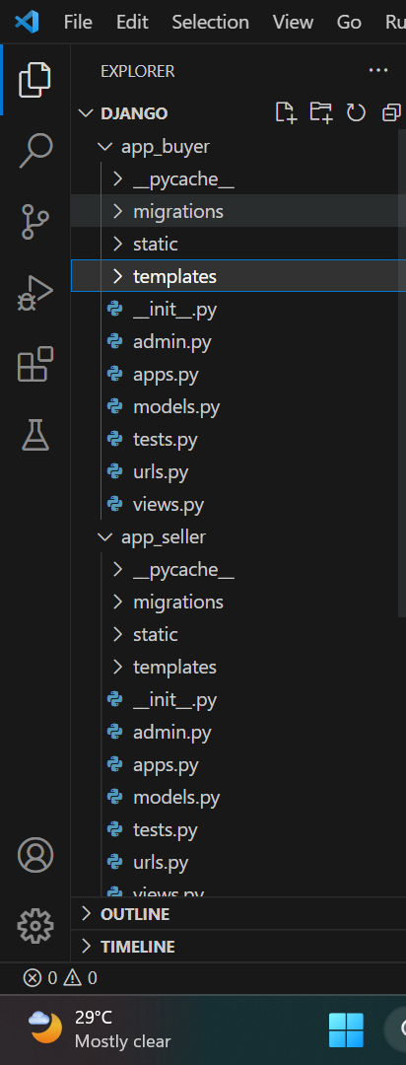

Fig 1.7 File and Folder Structure

1. Indentation and Spacing: Use consistent indentation and spacing throughout the project. Use two spaces for indentation and avoid using tabs. Use whitespace to make the code more readable and easier to understand.

1. Comments: Use comments to explain the code and make it easier for other developers to understand what the code is doing. Use clear and concise comments that explain what the code is doing, but avoid over-commenting.

1. Naming Conventions: Use descriptive and meaningful names for variables, functions, and classes. Use camelCase for naming variables and functions, and Pascal Case for naming classes.

1. Error Handling: Implement proper error handling to prevent unexpected errors from occurring. Use try-catch blocks to catch errors and handle them appropriately.

1. Code Reusability: Write code that is reusable and modular. Use functions and components to break down complex code into smaller, more manageable pieces.

1. Code Formatting: Use a consistent code formatting style throughout the project. Use a tool like Prettier to automatically format the code and ensure consistency.

1. Testing: Write tests to ensure that the code is working as expected. Use a testing framework like Jasmine or Jest to write and run tests.
2. Version Control: Use a version control system like Git to manage changes to the code. Use descriptive commit messages to explain the changes that were made.

By following these coding standards, the OSW project can have a clean, consistent, and maintainable codebase that is easy to understand and modify.

#### 7.4 Prototype Screen Shots

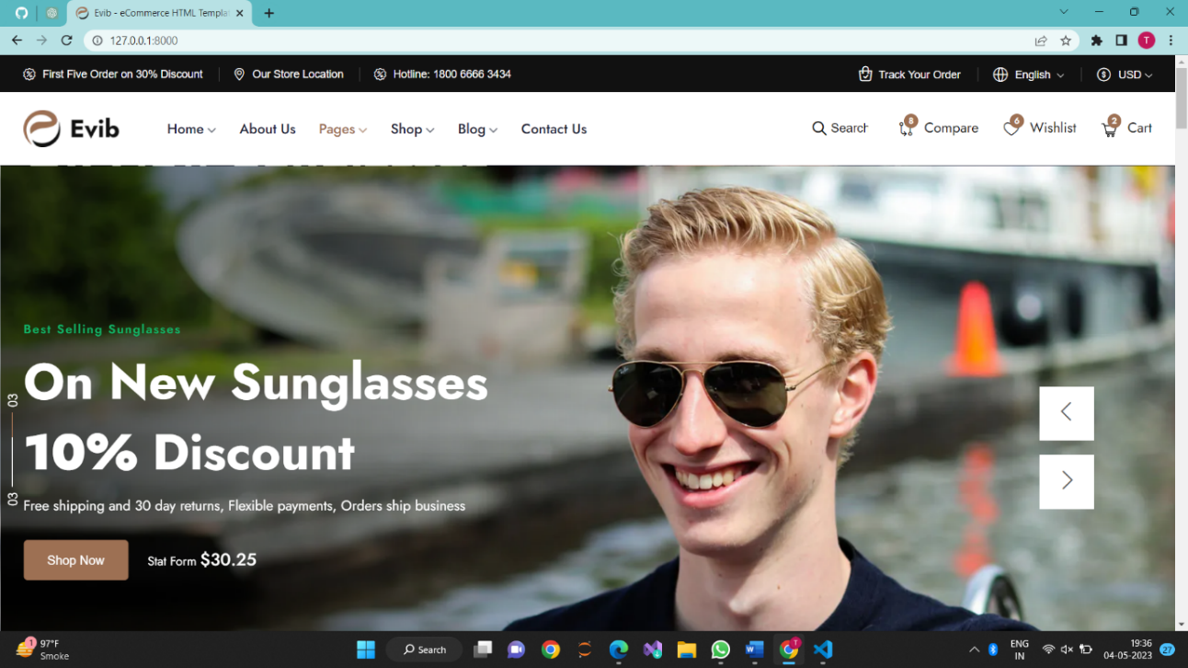

Fig 1.8 Landing page

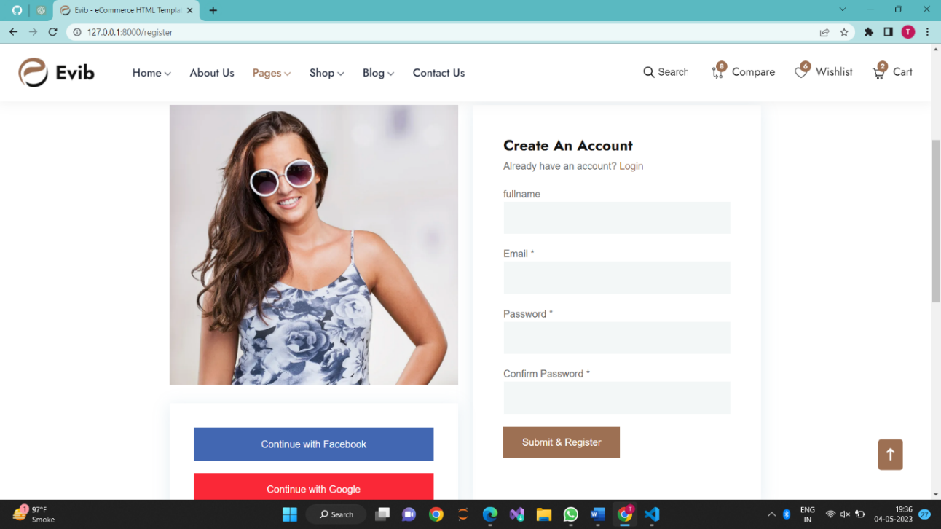

Fig 1.9 Register page

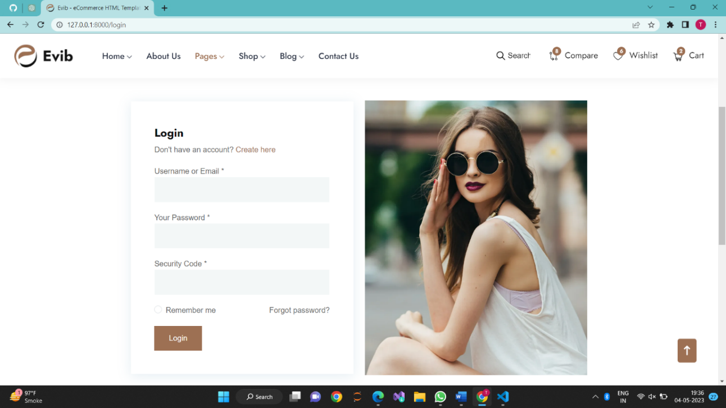

Fig 1.10 Login page

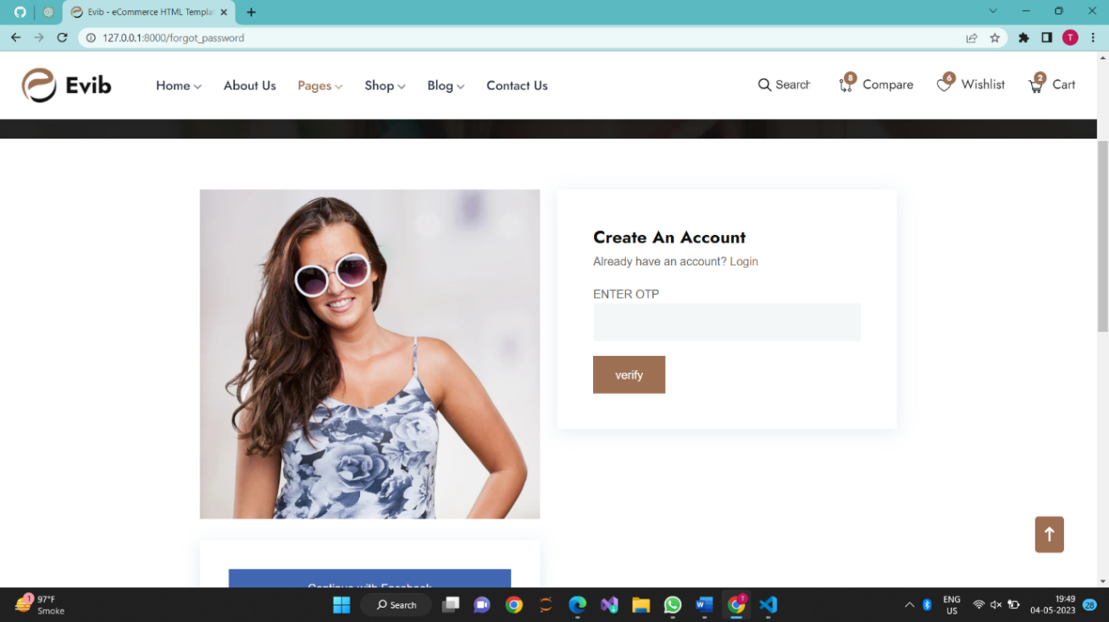

Fig 1.11 OTP page

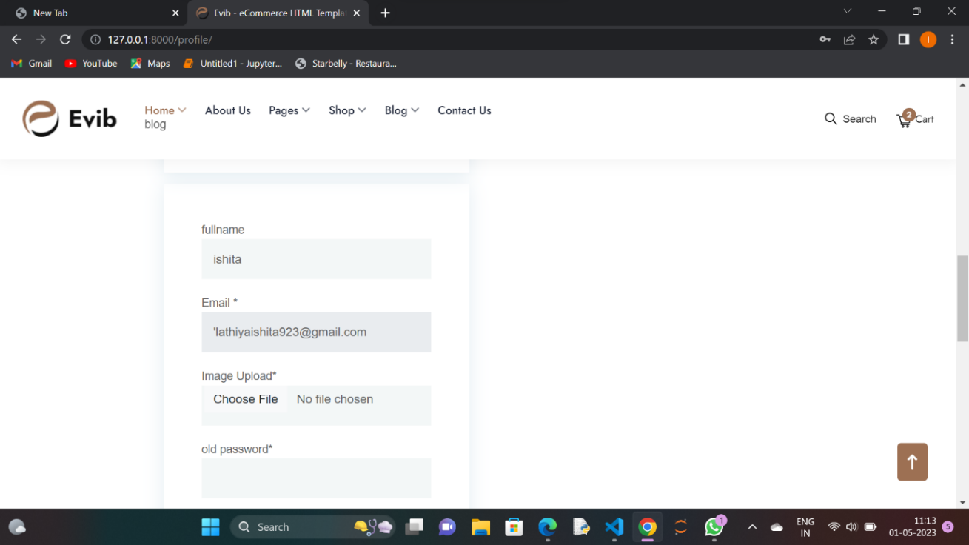

Fig 1.12 Profile page

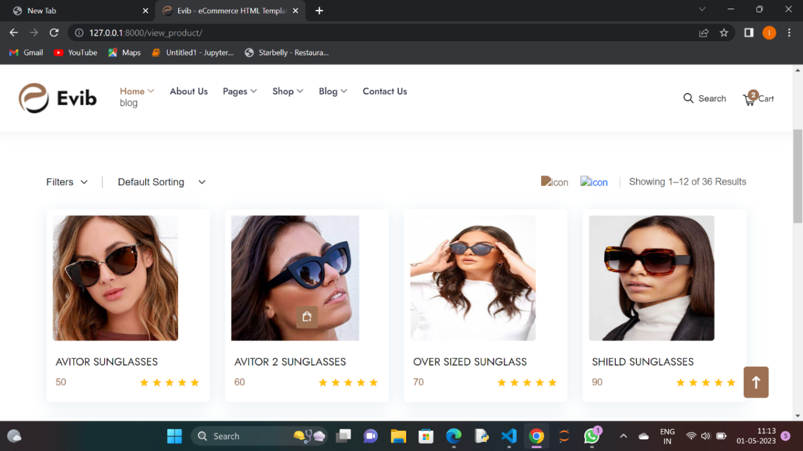

Fig 1.13 View product page

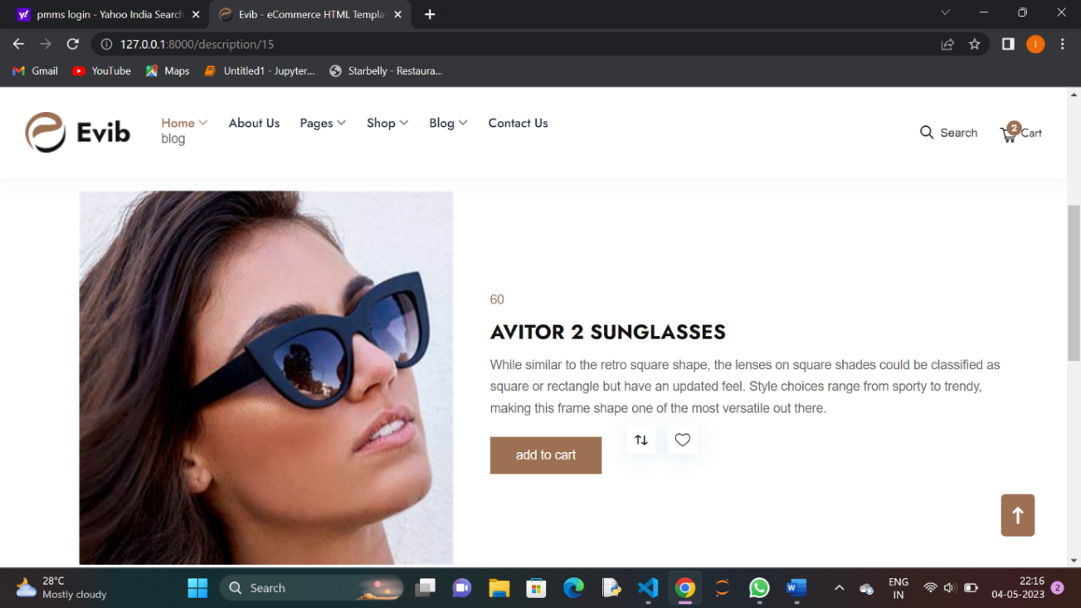

Fig 1.14 Product description page

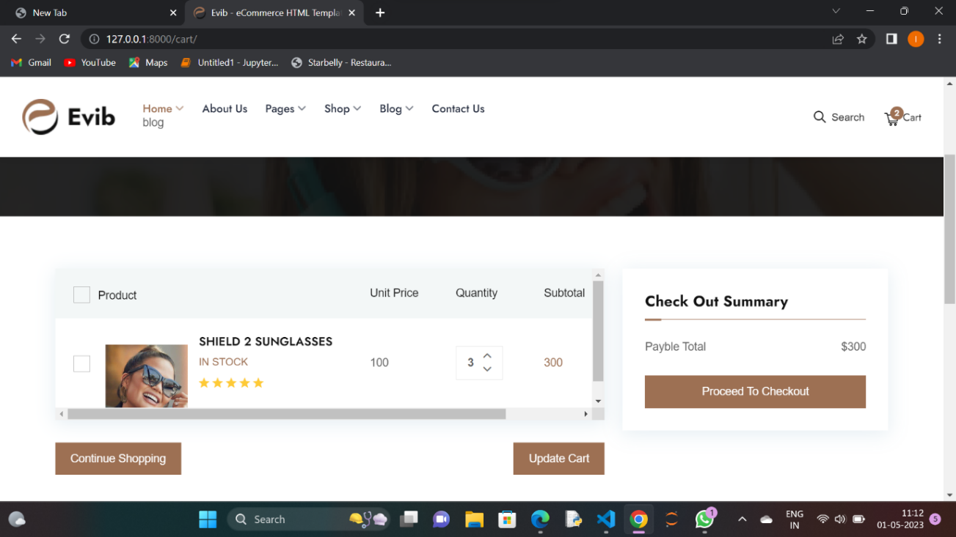

Fig 1.15 Shopping cart page

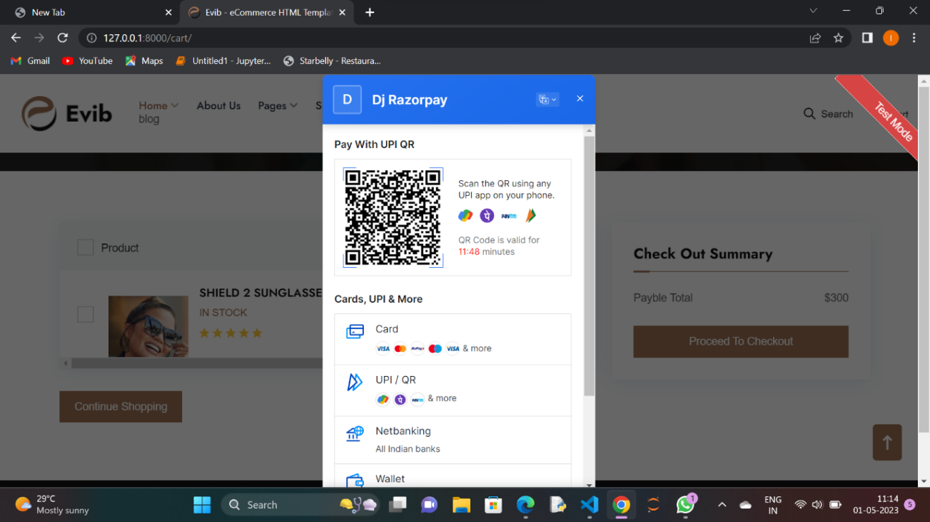

Fig 1.16 Payment gateway page

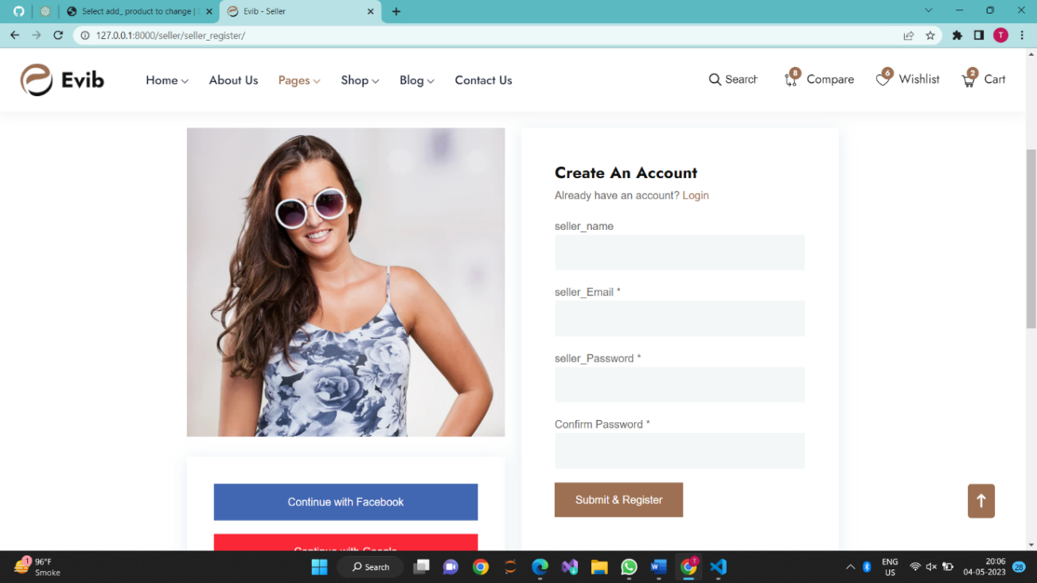

Fig 1.17 Seller register page

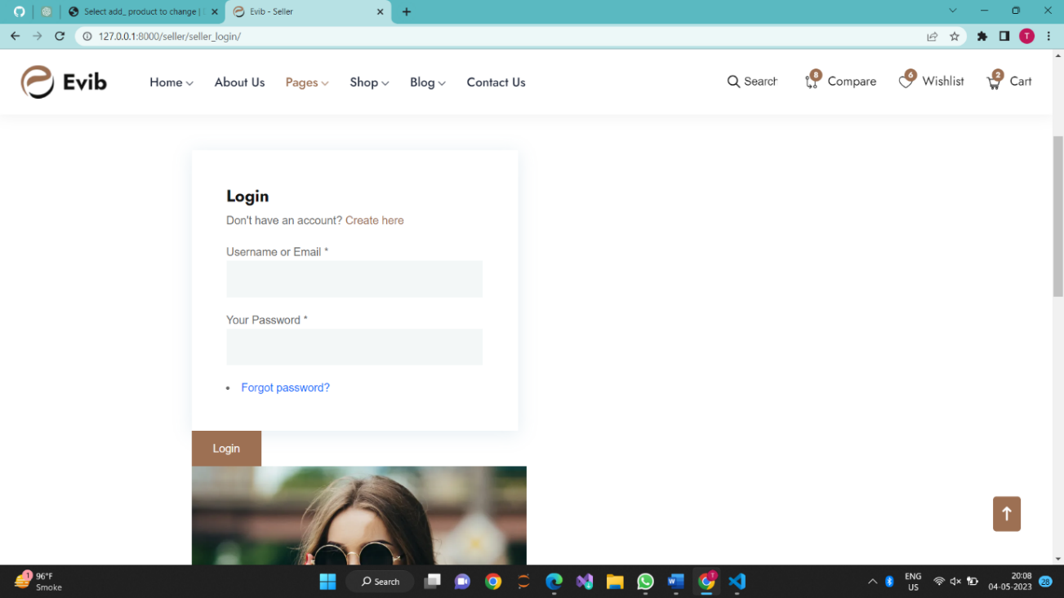

Fig 1.18 Seller login page

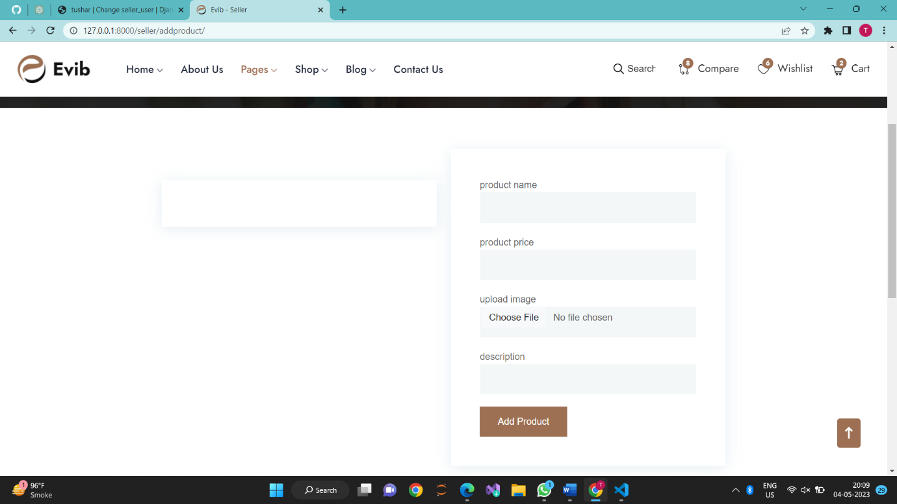

Fig 1.19 Add product page

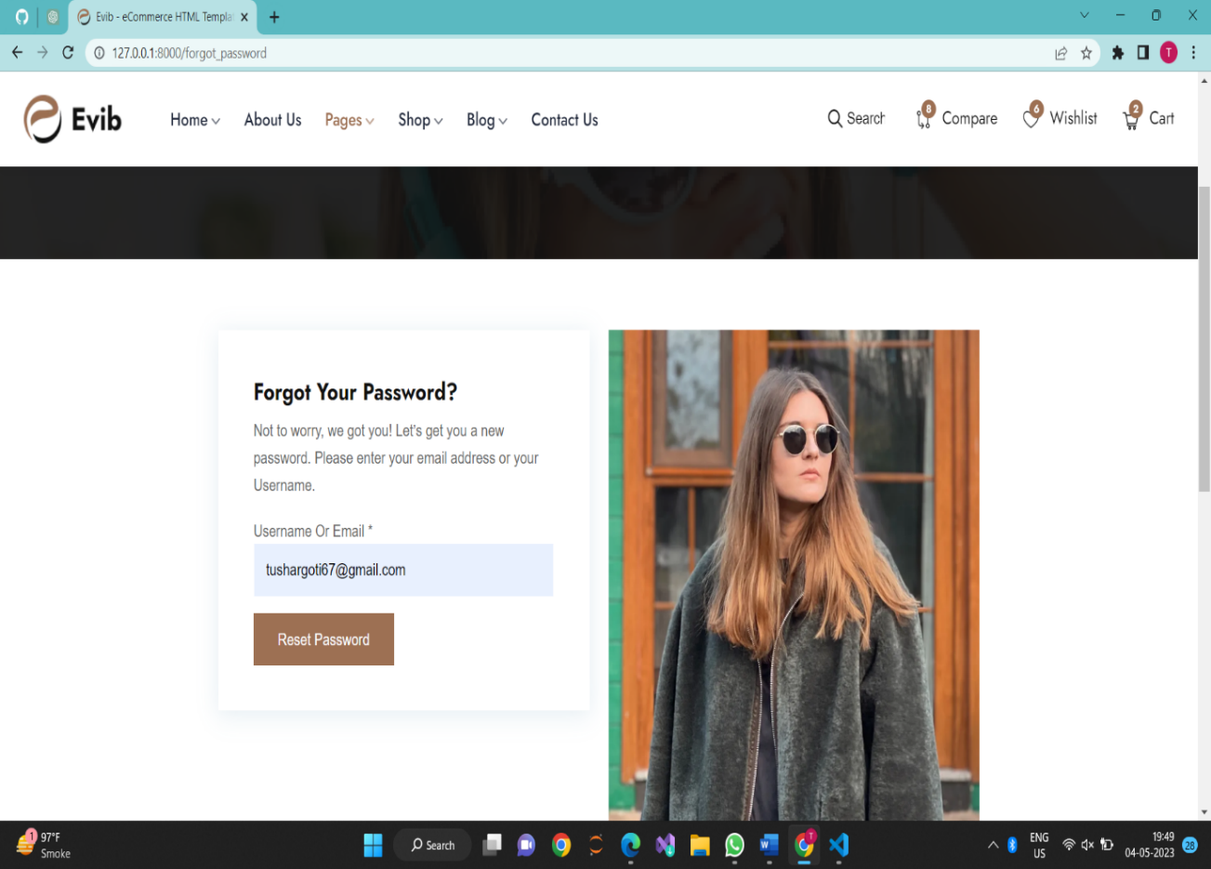

Fig 1.20 Forgot password page

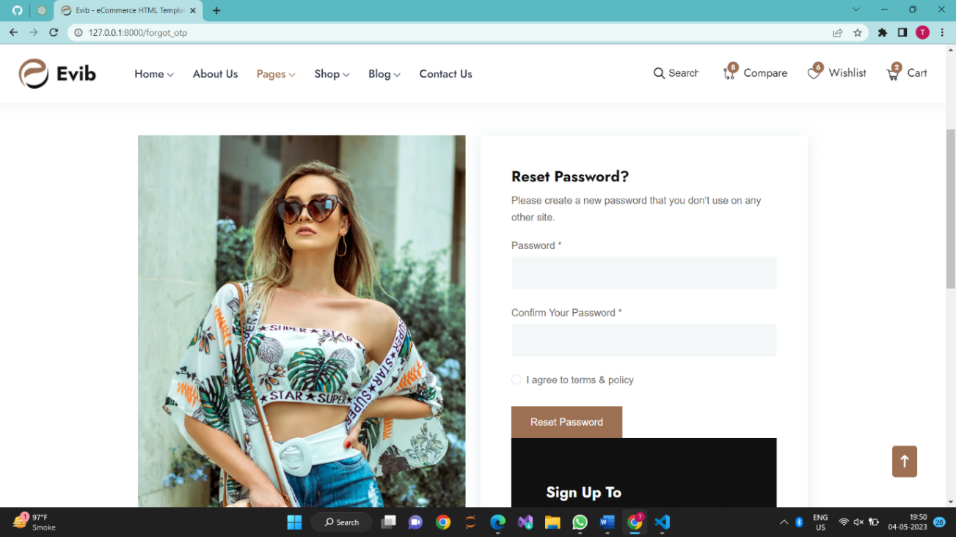

Fig 1.21 reset password page

### **Chapter – 8: Testing**

#### 8.1 Testing Plan

A testing plan for OSW should include the following steps:

1. Unit Testing: The individual modules of the system should be tested for their functionality and accuracy. This includes testing the Sales-Sprout, Inventory Management, expense management and schedular module to ensure that each module performs as intended.

1. Integration Testing: After the individual modules have been tested, they should be integrated and tested as a whole to ensure that they work together properly. This includes testing the integration of Sales-Sprout, Inventory Management, expense management and schedular module.

1. User Acceptance Testing: Once the system has been developed and integrated, it should be tested by end-users to ensure that it meets their requirements and expectations. This includes testing the Sales-Sprout, Inventory Management, expense management and schedular module from a user perspective.

1. Performance Testing: The system should be tested to ensure that it performs well under expected workloads. This includes testing the Sales-Sprout, Inventory Management, expense management and schedular module under high loads to ensure that the system performs as expected.

1. Security Testing: The system should be tested to ensure that it is secure and that user data is protected. This includes testing the Sales-Sprout, Inventory Management, expense management and schedular module for security vulnerabilities and ensuring that appropriate security measures are in place.

1. Regression Testing: After each change to the system, it should be tested to ensure that no other parts of the system have been affected. This includes testing the Sales Sprout, Inventory Management, expense management and schedular module after each update or change to the system.

1. User Training Testing: The system should be tested to ensure that it is easy to use and understand for end-users. This includes testing the Sales-Sprout, Inventory Management, expense management and schedular module with end-users to ensure that they can use the system effectively.

By following these testing steps, the online shopping website system can be thoroughly tested and ensured to be functioning properly.

#### 8.2 Testing Strategy

The testing strategy for the online shopping website project can include the following steps:

1. Test Planning: The testing team should prepare the test plan, which outlines the testing approach, scope, objectives, and timelines.

1. Test Design: The testing team should design test cases that cover all the functional and non-functional requirements of the system.

1. Test Execution: The testing team should execute the test cases to validate that the system works as expected.

1. Defect Reporting: The testing team should report any defects found during testing to the development team so that they can be fixed.

1. Retesting: The testing team should retest the system after the defects have been fixed to ensure that the fixes are successful.

1. Acceptance Testing: Once the testing team has completed their testing, the system should be subjected to user acceptance testing to ensure that it meets the requirements of the end-users.

1. Regression Testing: Any time changes are made to the system, regression testing should be performed to ensure that the changes have not introduced new defects or broken existing functionality.

The testing strategy should aim to ensure that the online shopping website is fully functional, reliable, and user-friendly. The testing team should use a combination of manual and automated testing methods to ensure that all aspects of the system are thoroughly tested. Additionally, the testing team should work closely with the development team throughout the development lifecycle to ensure that any issues are identified and addressed as early as possible.

### **Chapter – 9: Conclusion and Discussion**

#### 9.1 Problem Encountered and Possible Solutions

During the development and implementation of the online shopping website project, several problems may be encountered. Some possible problems and solutions are:

1. Integration issues: One of the main challenges of implementing this online system is integrating the different modules, including adding product, view product To solve this problem, proper planning and coordination should be done between the development team and stakeholders to ensure that all modules work seamlessly.

1. Data migration issues: Migrating data from the earlier online system, which is based on data, to this system may pose a challenge. The solution to this problem is to conduct a thorough data analysis and mapping before migration. Also, data cleansing and validation should be done to ensure data accuracy.

1. Technical issues: Technical problems such as system crashes, software bugs, and network issues can hinder the smooth running of the project. To mitigate these issues, proper testing and quality assurance should be done before the system goes live. Also, regular maintenance and updates should be done to prevent technical problems.

1. Security issues: With sensitive employee and company data being stored in the system, security is a top concern. Measures such as data encryption, access control, and regular security audits should be implemented to prevent unauthorized access and data breaches.

Overall, by addressing these potential problems and implementing solutions, online shopping website can be successfully developed and implemented, offering several advantages over the earlier online shopping website system based on past data.

### **Chapter – 10: Limitation and Features Enhancement**

#### 10.1 Advantage

The advantages of the online shopping website system based on past data are:

1. Convenience and time : An online optical shop offers the same convenience as any other e-commerce website where you can freely scroll and window shop till you find something you like and get it instantly. Be it finding specific products or the benefit of being able to shop from anywhere, the experience of buying eyeglasses online is genuinely convenient.

1. Countless options to choose from : Buying eyeglasses online is advantageous not just because it will save your time, but also allows you access to a massive selection of frames. When you are at a store, you will effectively have to wade through a bunch of different glasses styles that do not appeal to you, only to discover that the options you would prefer is limited.

1. Cost effective : The price of glasses is one significant advantage of purchasing eyeglasses online. Most, if not all, internet retailers charge less for their spectacles than physical stores. And you may have heard why, but it is mostly because internet suppliers tend to eliminate the supply chain’s intermediary. The supply chain is eliminated because the manufacturer directly sells to the customer when you purchase eyeglasses online. As a result, they can keep glasses costs cheap without sacrificing quality—a big plus for anyone seeking a good set of eyeglass frames without spending a fortune.

#### 10.2 Disadvantage

Some potential disadvantages of a modern online shopping website system over an earlier based on past data include:

1. Sizing errors : When purchasing eyeglasses online, you are unable to try the eyeglasses on for optimal fit. There will also be no professional on hand to take the appropriate measurements. To get the best vision off your glasses, you will need to take numerous measurements. The pupillary distance (PD), optical centers, and

segment height are the most important. Although many internet merchants provide a ruler for you to take your own measures, an erroneous and unskilled measurement can negate the advantages of an updated prescription.

1. You will not get a personalized services : You may pay more from the pocket when purchasing eyewear from your optometrist’s office, but you will receive individualized care in exchange for your eyewear being particularly well suited for you providing long-term benefits

### Conclusion

In conclusion, building an eyewear website using Django can be a great choice for developers looking to create a high-quality, feature-rich website. By leveraging Django's built-in features and third-party packages, developers can create a robust and scalable platform that meets the needs of both the business and its customers.

### References

1. **Virtual Studio Code:** <https://code.visualstudio.com/>
2. **Django:** <https://www.djangoproject.com/>
3. **DB Browser(SQL lite):** https://sqlitebrowser.org/dl/
4. **W3Schools:** <https://www.w3schools.com/django/>
5. **Payment :** https://razorpay.com/